***MUI 121022***

FilterCheck

User Manual

**7506 Holley Circle**

**Panama City Beach, FL 32408**

**December 10th, 2022**

Table of Contents

Revision Table 3

**Overview:** 4

**User Safety Tips:** 4

**Device Operation:** 5

**Preforming a Calibration Check:** 9

**Charging the Device** 11

Directions: 11

**Conclusion:** 12

# Revision Table

|  |  |  |  |  |
| --- | --- | --- | --- | --- |
| Date | Revision Number | Change Description | Job Title | Initials |
| 12/10/2022 | 0 | Document Created | Software Engineer | LAD |
|  |  |  |  |  |
|  |  |  |  |  |
|  |  |  |  |  |
|  |  |  |  |  |
|  |  |  |  |  |
|  |  |  |  |  |

# **Overview:**

This Document’s purpose is to give information to a FilterCheck user on the procedures they must follow to operate the FilterCheck and the process of completing a FilterCheck Calibration Check.

# **User Safety Tips:**

* To avoid damage to FilterCheck components, make sure the device is powered down before shutting the lid.
* It is recommended to use the device in cleaner environments to maximize the devices service life.
* To avoid potential damage or shock do not take the FilterCheck apart.
* Store the device with a dust plug to protect the internal components from dirt.
* To avoid clogs/blockages clean the metal screen that is inserted into the flow port.
* To avoid damage to the electronics do not intentionally submerge in water.
* To avoid damage to the electronics only charge the device at 30v with a minimum of 2A.

# **Device Operation:**

1. Remove the Dust Plug

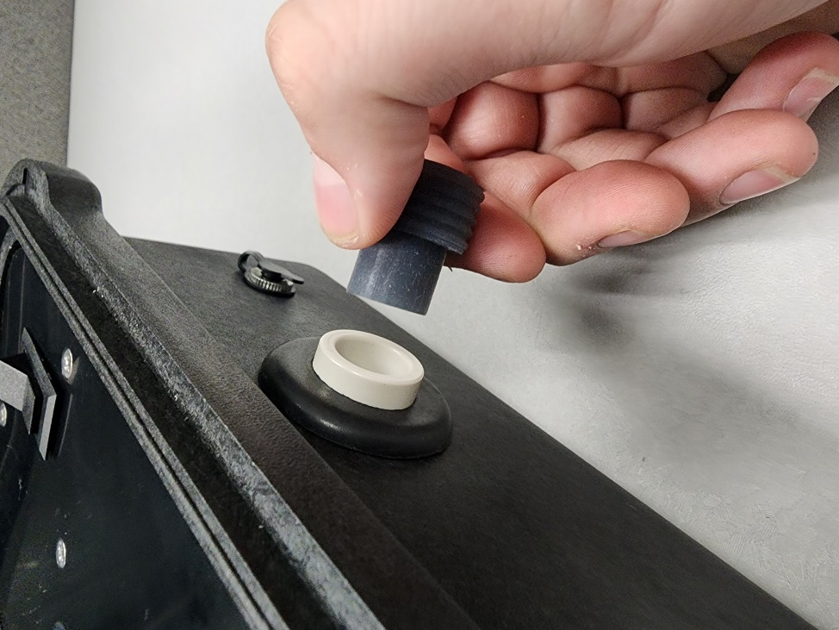

1. Turn on the Power Switch

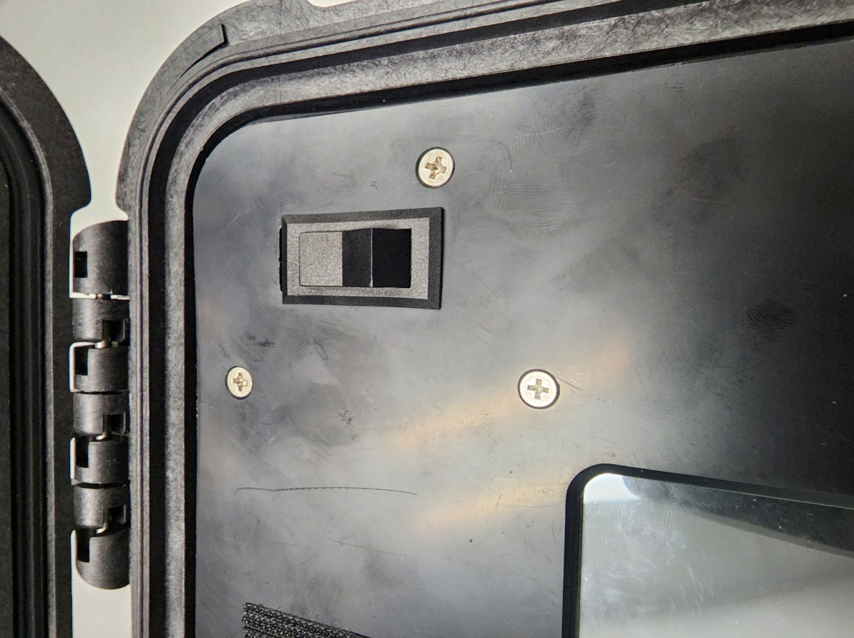

1. A blinking Blue LED represents the device is initializing (estimated initialization time: 45 seconds)

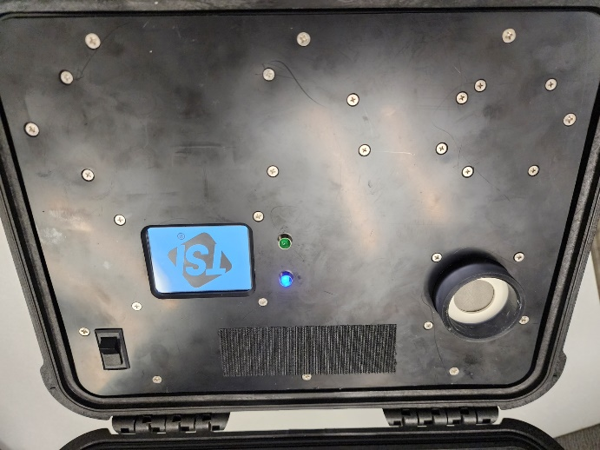

1. A solid Green LED represents the device is ready to test filters

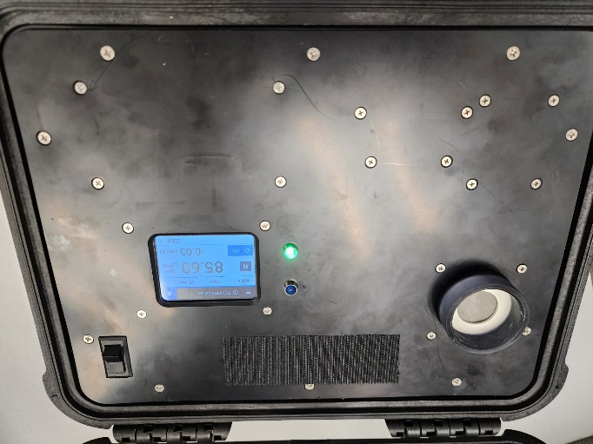

1. Verify the system to be calibrated:
   * The flow rate must be within the tolerance of 85 ± 1.19 SLPM (83.81 to 86.19 Standard Liters per Minute)
     + Standard Temperature & Pressure (STP) (760 mmHg & 0° Celsius)
   * The low-pressure readings must be within the tolerance of 0 ± .06 cmH2O (-.06 to .06 Centimeters of Water)

1. Insert a filter to begin testing
2. A blinking Green LED represents the device is analyzing the filter & is adjusting the flow rate back to the required 85 ± 1.19 SLPM (83.81 to 86.19 SLPM)

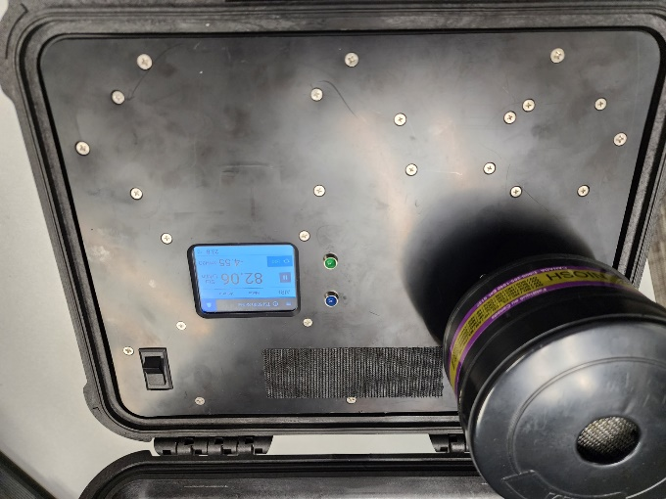

1. The Green LED will stop blinking and turn back solid to represent flow is stable and the test has been completed

1. Press the pause button & record the resulting pressure being displayed

1. Press the resume button & remove the filter
2. a Blue LED will blink representing the device is zeroing

# **Preforming a Calibration Check:**

1. Complete up to Step: 5 (“Insert a filter to begin testing.”) of the **Device Operation** instructions
2. Insert the included Verification Orifice to begin the Calibration Check

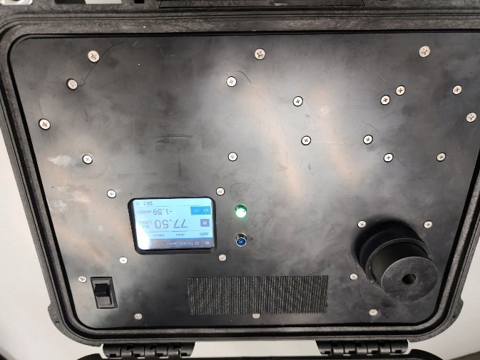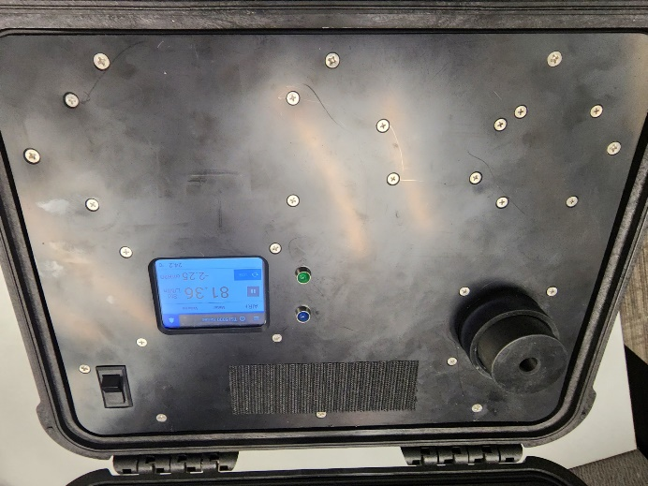

1. Complete up to Step: 8 (“Press the pause button & record the resulting pressure being displayed”) of the **Device Operation** instructions
2. Verify the measured pressure to be -2.4 ± 10% cmH2O (-2.16 to -2.64 Centimeters of Water)

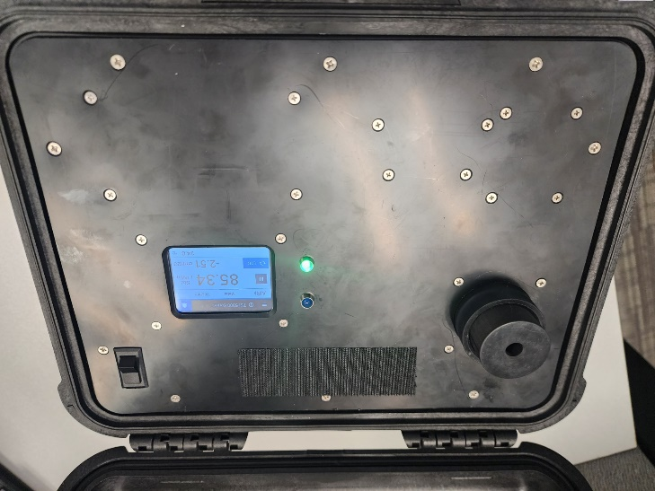

1. Remove the Verification Orifice & a Blue LED will blink representing the device is zeroing

1. You have now completed the Calibration Check
2. To test filters, continue from Step: 5 (“Insert a filter to begin testing.”) of the **Device Operation** instructions

# **Charging the Device**

* There is an internal Rechargeable Battery inside the FilterCheck.
* The FilterCheck has approximately an 8-hour run-time on a single charge.
* The internal Rechargeable Battery has an over-charge cut-off switch that protects the device from being left on the charger to long.
* Recommended to charge while not in use, so the FilterCheck doesn’t have to be plugged in to operate.
* The FilterCheck passively charges the internal Rechargeable Battery when plugged into a wall outlet.

## Directions:

1. Plug the 30v Power Supply into a wall outlet.
2. Plug the 30v Power Supply’s barrel connector into the FilterCheck

# **Conclusion:**

This concludes the FilterCheck’s User Manual. For questions and/or concerns regarding the FilterCheck please contact **Ator Labs** at: [LAD@AtorLabs.com](mailto:LAD@AtorLabs.com).